Data Cards Activity: Small and Medium-Size Cities and Health Equity

Materials You Need
- Index Cards or Card Stock (for the data deck)
- Drawing utensils, such as color pencils or crayons

Before you begin…
- Identify which grade band your class belongs in:
  - Grade Band I: Grades 3 – 5 (elementary school)
  - Grade Band II: Grades 6 – 8 (middle school)
  - Grade Band III: Grades 9 – 12 (high school)
This activity is meant for Grade Bands I or II and is an alternative activity to the City Health Data Story in the “five subsection” structure.

- Read through the guide and the accompanying Google Slides.
- Pick at least ten different cities from the data.
- Create data cards based on the cities you picked, which becomes a data deck. See this example here.
- Make enough data decks for each group of students (three to four students per group) for your class.

Slide Content | Instructor Notes
Introduction (no learning goal for this subsection)
Read over the introduction paragraph provided on the slide.
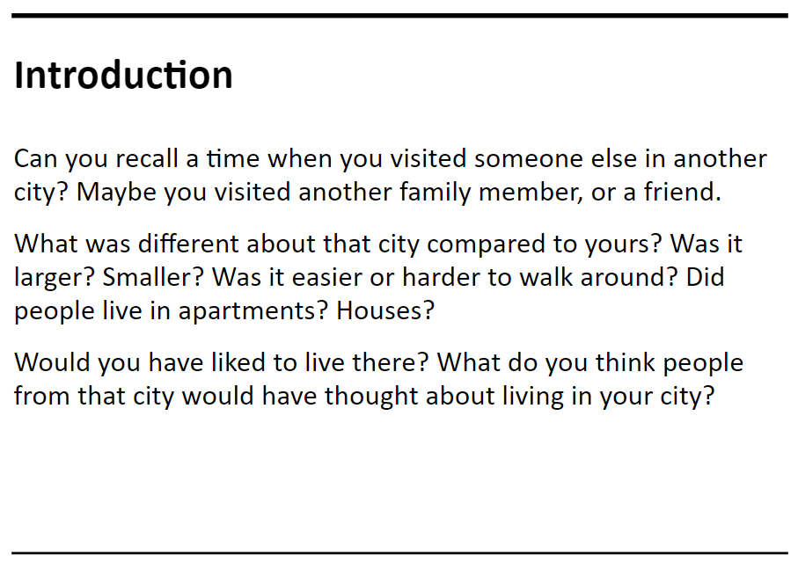  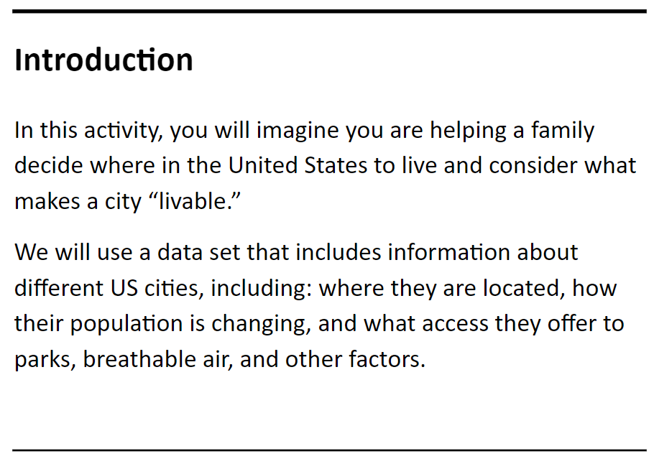 | Can you recall a time when you visited someone else in another city? Maybe you visited another family member, or a friend.  What was different about that city compared to yours? Was it larger? Smaller? Was it easier or harder to walk around? Did people live in apartments? Houses?  Would you have liked to live there? What do you think people from that city would have thought about living in your city?  In this activity, you will imagine you are helping a family decide where in the United States to live and consider what makes a city “livable.”  We will use a data set that includes information about different US cities, including: where they are located, how their population is changing, and what access they offer to parks, breathable air, and other factors.
Time to look at the data!

Show the class the data and give about 5 minutes for them to observe the data before moving onto the first subsection.

Download the excel sheet here.
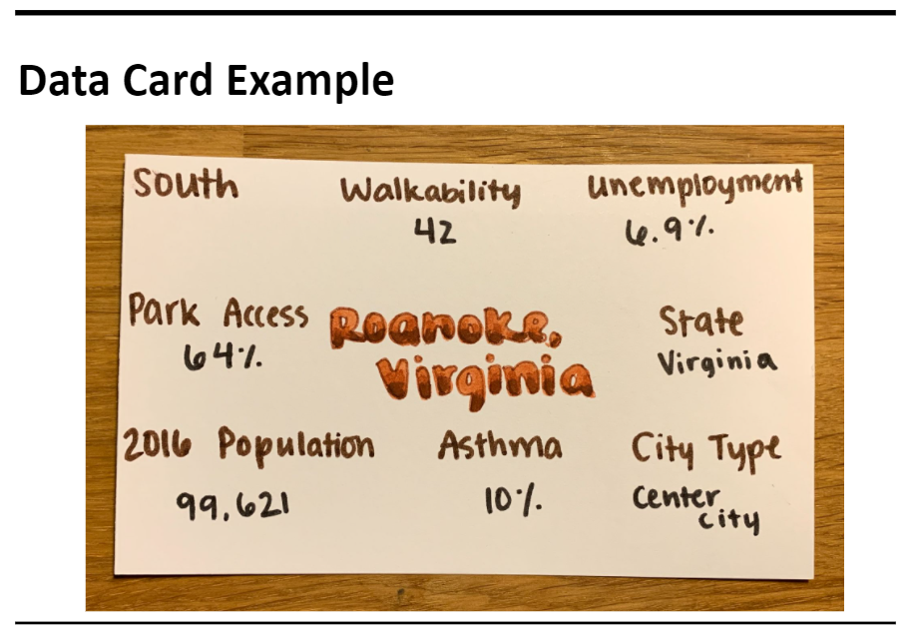  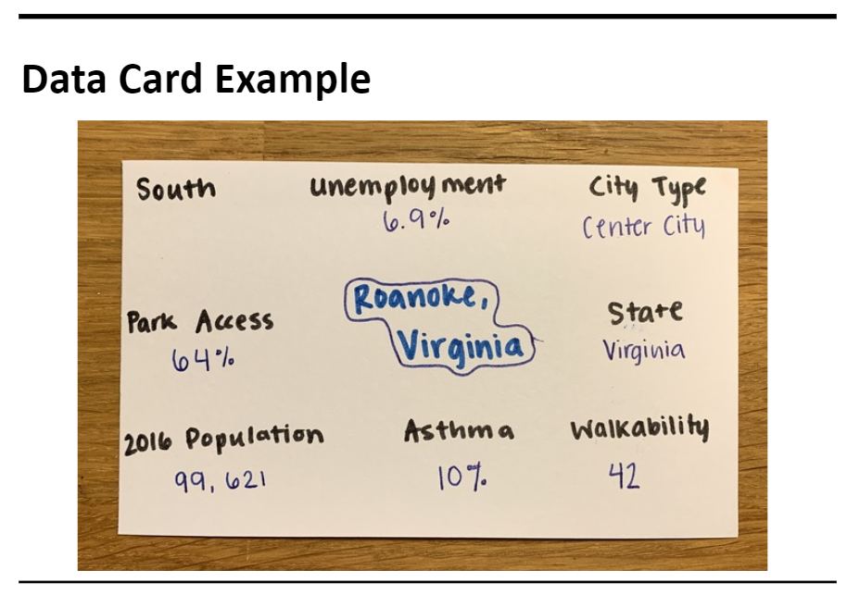 | Create Data Cards  Hand out index cards (or card stock) and the drawing utensils to your students. Have the students pick a city from the data and make a data card.  See the slides for examples.
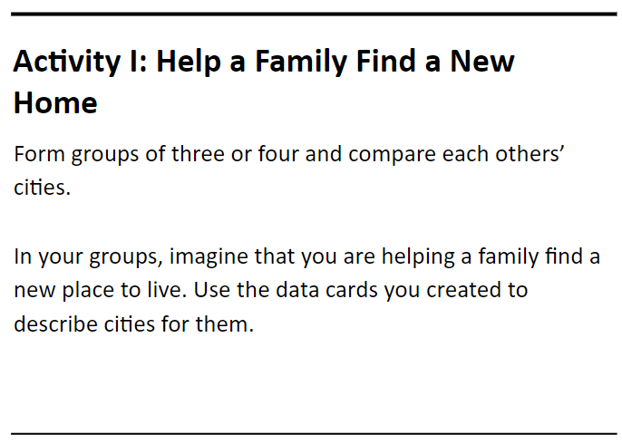 | Activity 1: Help a Family Find a New Home  Form groups of three or four and compare each others’ cities.  In your groups, imagine that you are helping a family find a new place to live. Use the data cards you created to describe cities for them.
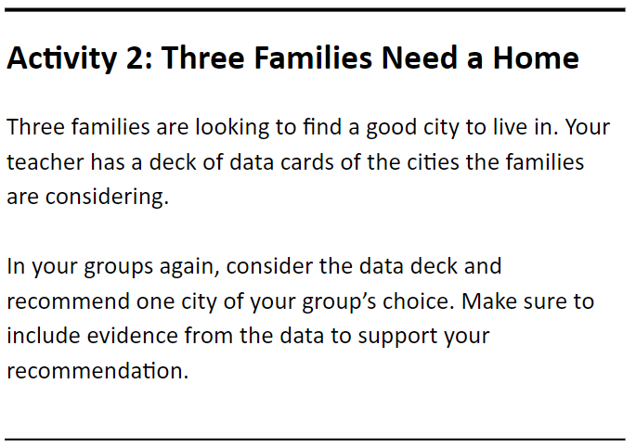 | Activity 2: Three Families Need a Home  Three families are looking to find a good city to live in. Your teacher has a deck of data cards of the cities the families are considering.  In your groups again, consider the data deck and recommend one city of your group’s choice. Make sure to include evidence from the data to support your recommendation.
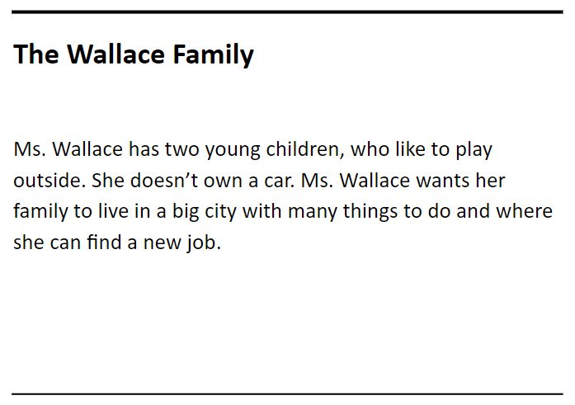 | The Wallace Family  Ms. Wallace has two young children, who like to play outside. She doesn’t own a car. Ms. Wallace wants her family to live in a big city with many things to do and where she can find a new job.
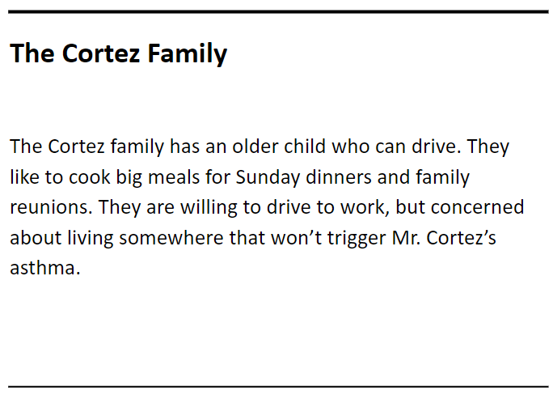 | The Cortez Family  The Cortez family has an older child who can drive. They like to cook big meals for Sunday dinners and family reunions. They are willing to drive to work, but concerned about living somewhere that won’t trigger Mr. Cortez’s asthma.
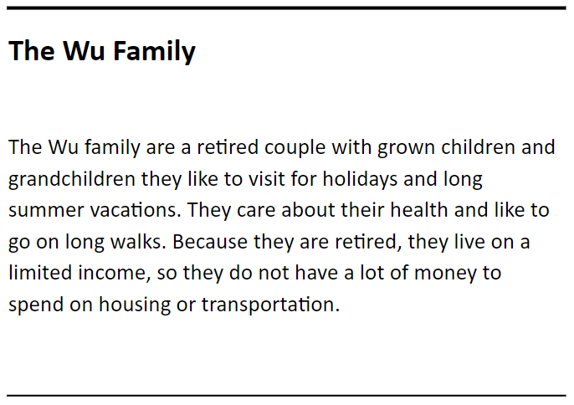 | The Wu Family  The Wu family are a retired couple with grown children and grandchildren they like to visit for holidays and long summer vacations. They care about their health and like to go on long walks. Because they are retired, they live on a limited income, so they do not have a lot of money to spend on housing or transportation.
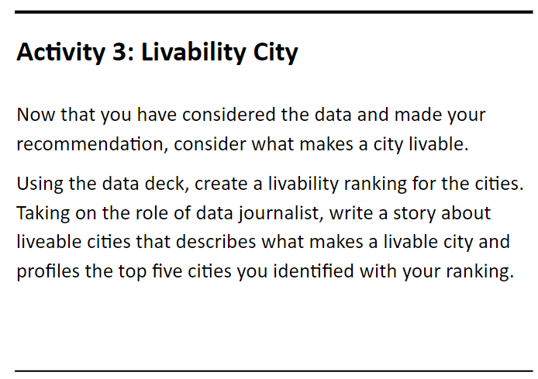 | Activity 3: Livability City  Now that you have considered the data and made your recommendation, consider what makes a city livable.  Using the data deck, create a livability ranking for the cities. Taking on the role of data journalist, write a story about liveable cities that describes what makes a livable city and profiles the top five cities you identified with your ranking.
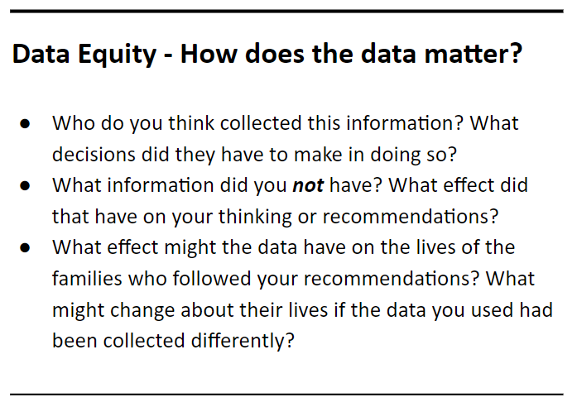 | Data Equity - How does the data matter?  Ask your students the following questions:  - Who do you think collected this information? What decisions did they have to make in doing so?  - What information did you not have? What effect did that have on your thinking or recommendations?  - What effect might the data have on the lives of the families who followed your recommendations? What might change about their lives if the data you used had been collected differently?  Students should learn that failing to account for representation in the data could cause further inequalities.

